WILL THE GOVERNMENT ALLOW GENERAL AVIATION TO SURVIVE IN AUSTRALIA?

Dear Senators,

May we express our thanks for your interest and concern of the plight General Aviation (GA) in Australia is facing.

The heading above is a simple enough question to ask of politicians, because fundamentally any answer must be a political one.

If the answer is no then we just continue along the same path we are on.
General Aviation is in steep decline and the gradient is getting ever steeper.

If the answer is yes, a solution becomes much more complex.

To make a yes answer become reality some fundamental changes to the laws and governance of Aviation in Australia will be required.

We recognise that governance is not the only problem facing GA, but it’s true reform must occur if GA is to survive and have any chance of growth.

A yes answer to the heading question raises another self-evident question.

“Does the Australian Government want General Aviation in Australia to be safe”?

Of course the answer is obvious, the real question is, How Safe?

If the governance of General Aviation in Australia continues on its current path the industry will contract to be negligible and therefore statistically safer because very few will be flying.

If a balance is struck between viability and affordably safe, then there is a chance the industry might survive and grow.

Those countries in the world that have struck that balance have viable General Aviation industries, those that do not, don’t.

Interestingly the USA has a vastly different approach to governance than Australia. Their GA industry is healthy and contributes significantly to their economy.

Statistically they are also much safer than Australia.

This document focuses on the issue of governance.

The Civil Aviation Safety Authority (CASA) is empowered by the Civil Aviation Act 1988 (Act) to regulate Aviation.

They do this by legislation that must consider safety as its primary consideration.

Safety as a concept is impossible to define.

Safety, as a word is repeated throughout the Act yet there is certainly no definition of what safety is contained within it.

Therefore “Safety” and what it means becomes the subjective opinion of CASA who legislate based on what their opinion of what safety is.

If safety were required by government to be absolute, then CASA would have to shut down the whole industry, because no matter what the level of regulation, there would always be a level of risk whenever an aircraft is permitted to fly.

As nonsensical as it sounds CASA do have the power in theory to completely shutdown aviation. Politically however that would not be tolerated, therefore some level of risk must be accepted.

If red tape adds costs that are unsustainable, they threaten the very viability of the industry the legislation is enacted for, an equally nonsensical proposition. Therefore a regulator must consider the economic impact its legislation will have, otherwise the whole exercise is pointless if there is no Industry left for the regulations to apply to.

We understand politician’s reluctance to impugn government entities. The public service as we know is very powerful, but that should not be an excuse for ineptitude.

Lack of oversight and inaction by parliament is why our industry is in the dire position it is in today, literally being regulated out of business, with no increased safety benefit other than a mass exodus of participants out of the industry “Empty Skies are, after all safe skies”.

The volume, layers and complexity of regulation that exist in Australia do not exist anywhere else in the world.

In this missive we attempt to illustrate that effective safety can be achieved without imposing industry stifling red tape by making comparisons with like countries regulations, highlighting some of the more absurd and costly impositions our regulations impose and the legal minefield the industry must endeavour to operate within.

COMPARISONS

The picture below compares most but not all of the more prominent Australian regulations against the US Federal Aviation Regulations (FAR).

Australia’s are written in Legalise, understood by Lawyers, NOT pilots and engineers who must comply with them.

The FAR AIM booklet is the complete US rule set.

The FAR AIM rules are written in plain English

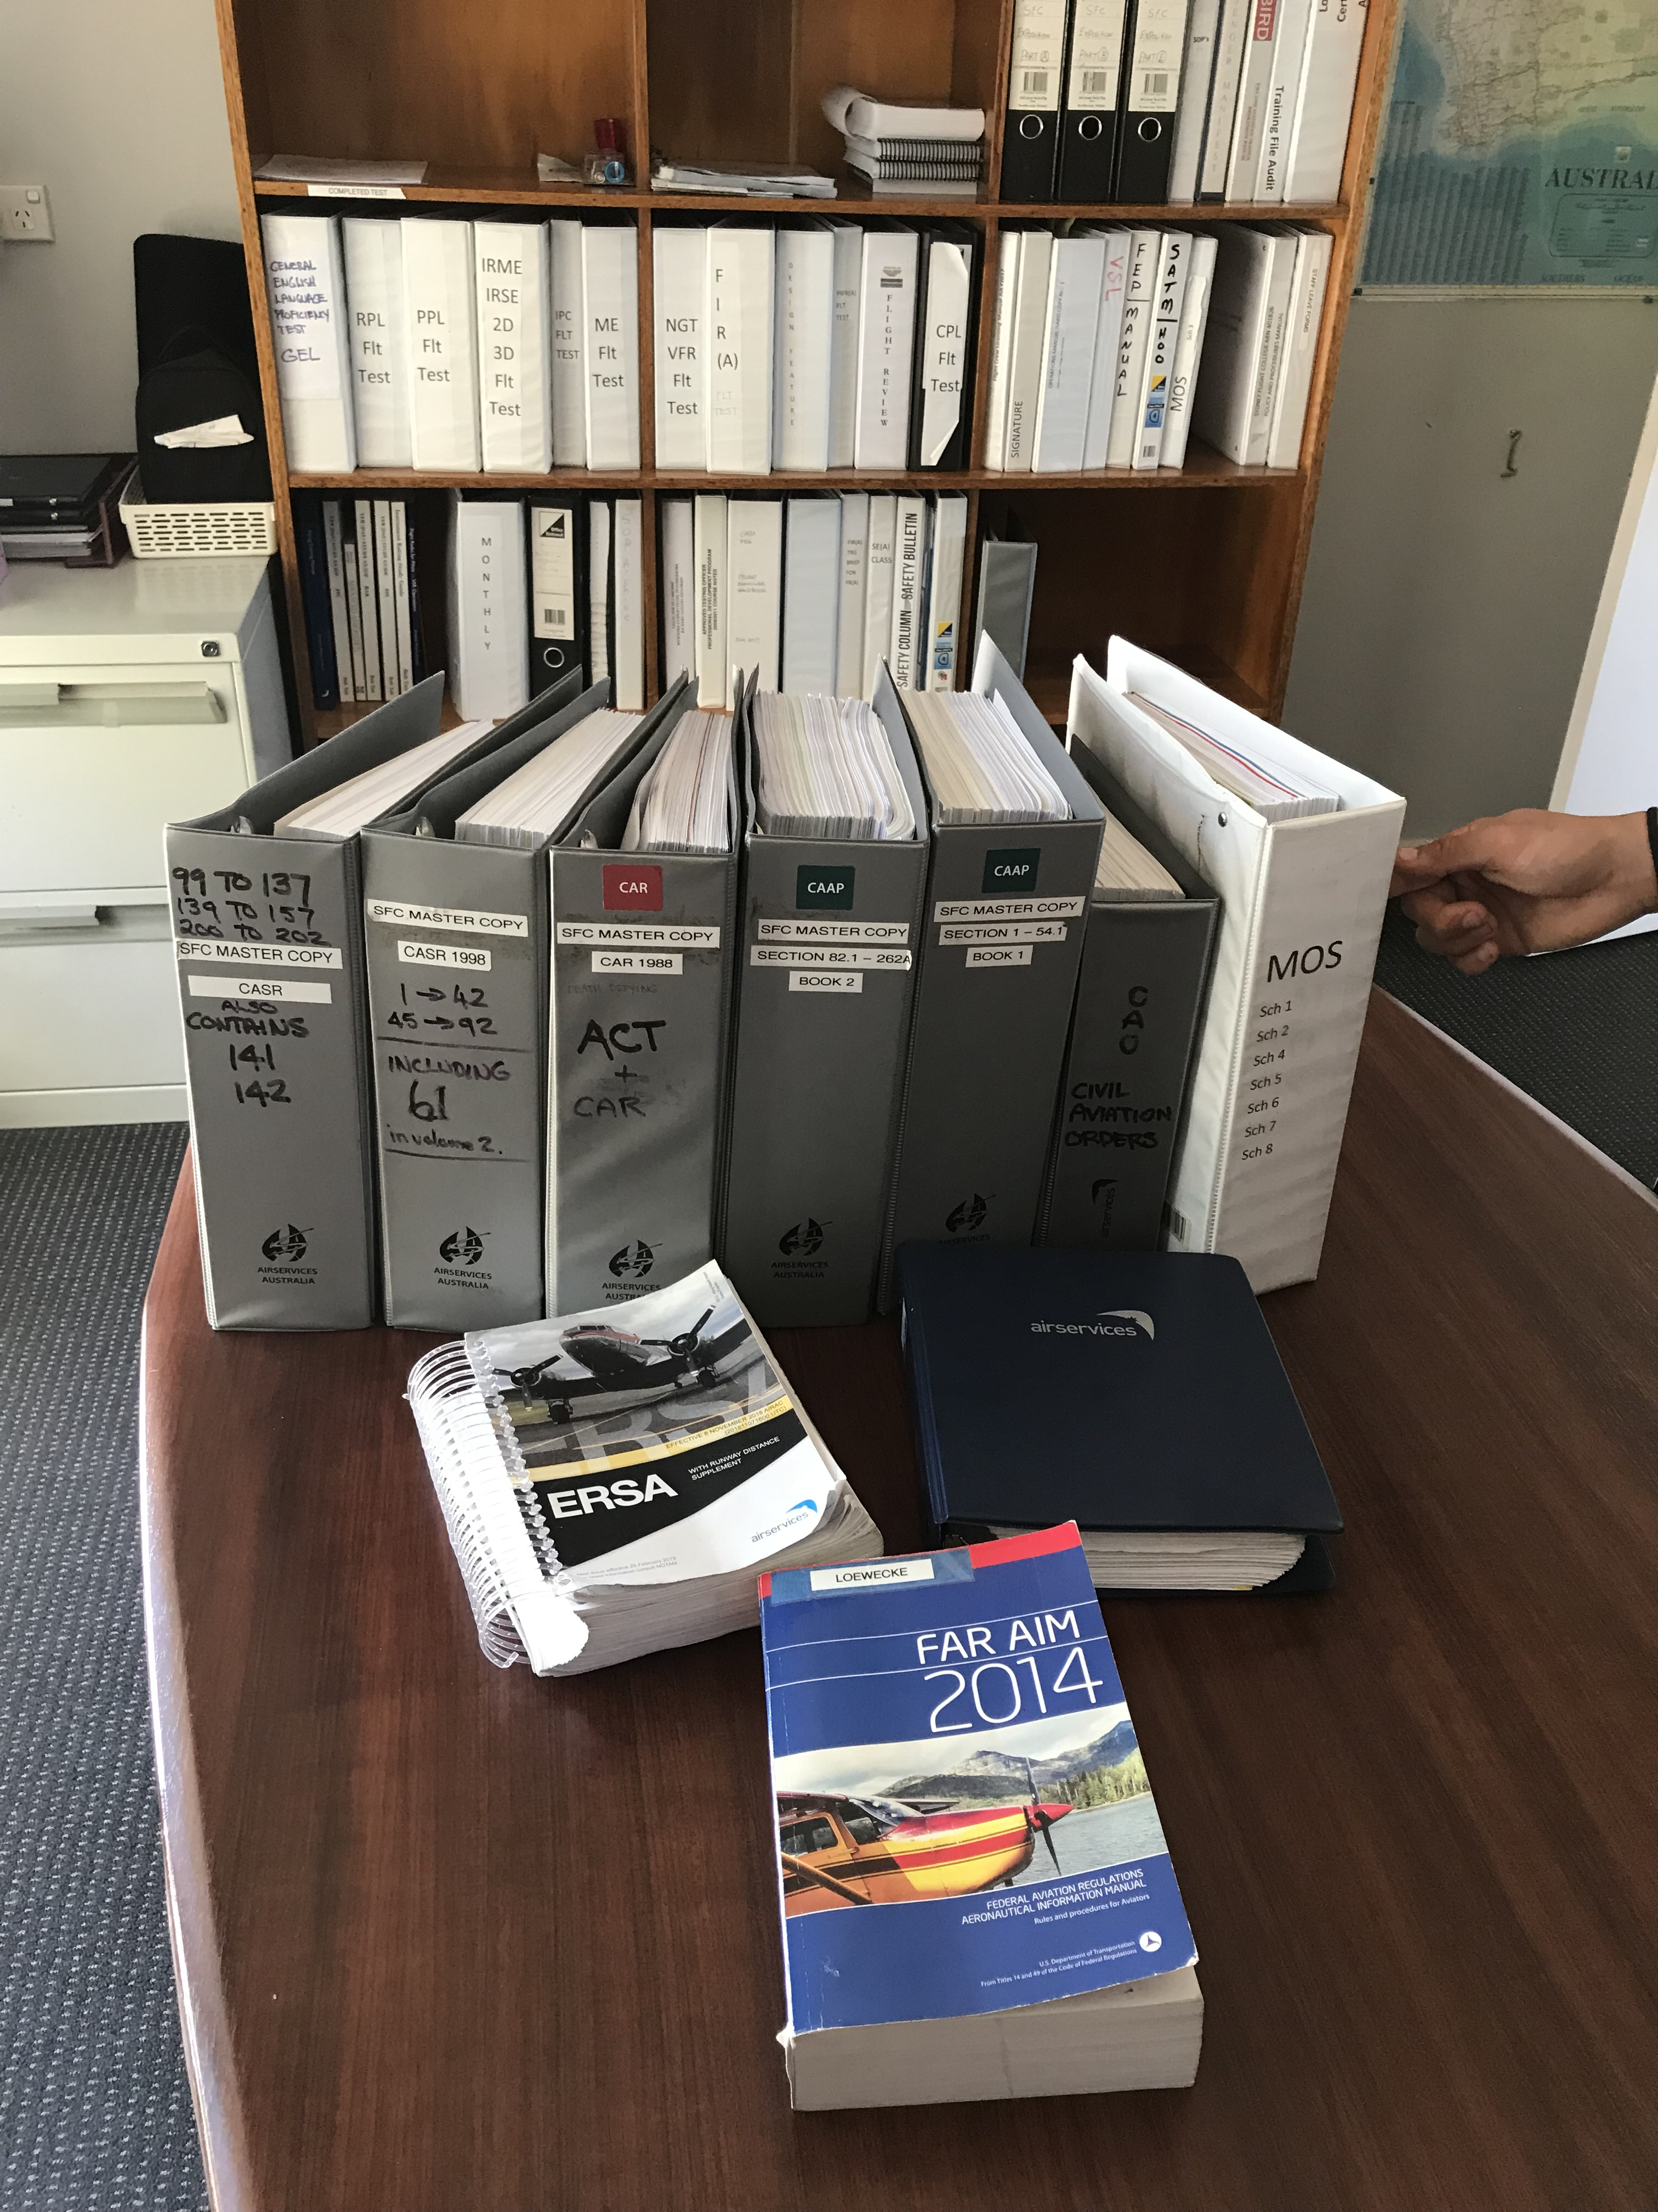

Why is there such a disparity?

The following analysis perhaps will give some understanding.

One Australian rule compared with the same rule in US and NZ regulations

Australia – 351 words | USA - 94 words | New Zealand - 96 words
91.060 Responsibility and authority of pilot in command .  (1) The operator of an aircraft must ensure that the following information is available to the pilot in command of the aircraft to enable the pilot in command to comply with sub regulation (5):  (a) the aircraft flight manual instructions for the aircraft;  (b) the airworthiness conditions (if any) for the aircraft;  (c) if the operator is required by these Regulations to have an operations manual — the operations manual;  (d) if the operator is required by these Regulations to have a dangerous goods manual — the dangerous goods manual.  Penalty: 50 penalty units.  (2) The pilot in command of an aircraft is responsible for the safety of the occupants of the aircraft, and any cargo on board, from the time the aircraft’s doors are closed before take-off until the time its doors are opened after landing.  (3) The pilot in command of an aircraft is responsible for the start, continuation, diversion (if any) and end of a flight by the aircraft, and for the operation and safety of the aircraft, from the moment the aircraft is ready to move until the moment it comes to rest at the end of the flight and its engine or engines are shut down.  (4) The pilot in command of an aircraft has final authority over:  (a) the aircraft while he or she is in command of it; and  (b) the maintenance of discipline by all persons on board the aircraft.  (5) The pilot in command of an aircraft must discharge his or her responsibilities under sub regulations (2) and (3) in compliance with the following:  (a) the aircraft flight manual instructions for the aircraft;  (b) the airworthiness conditions (if any) for the aircraft;  (c) the operations manual (if any) as it applies to the pilot in command;  (d) the dangerous goods manual (if any) as it applies to the pilot in command.  Penalty: 50 penalty units.  Note These Regulations also contain other requirements and offences that apply to the pilot in command of an aircraft.  (6) An offence against sub regulation (1) or (5) is an offence of strict liability. | 91.3 Responsibility and authority of the pilot in command.  (a) The pilot in command of an aircraft is directly responsible for, and is the final authority as to, the operation of that aircraft.  (b) In an in-flight emergency requiring immediate action, the pilot in command may deviate from any rule of this part to the extent required to meet that emergency.  (c) Each pilot in command who deviates from a rule under paragraph (b) of this section shall, upon the request of the Administrator, send a written report of that deviation to the Administrator. | 91.203 Authority of the pilot-in-command  Each pilot-in-command of an aircraft shall give any commands necessary for the safety of the aircraft and of persons and property carried on the aircraft, including disembarking or refusing the carriage of:  (1) any person who appears to be under the influence of alcohol or any drug where, in the opinion of the pilot-in-command, their carriage is likely to endanger the aircraft or its occupants; and  (2) any person, or any part of the cargo, which, in the opinion of the pilot-in-command, is likely to endanger the aircraft or its occupants.
Explanatory note by distinguished aviation journalist Paul Phelan
The Australian version, with exactly the same heading as the FAA uses, and similar to the NZ version, doesn’t even address the subject matter in the heading. It devotes the first 91 words (highlighted in blue typeface) to detailing some of the responsibilities of the operator – not the pilot in command. It then goes on to detail some (but not all) of the documents that CASA requires to be made available to the pilot in command during flight. These items are generally referred to as "shelfware"; a GA pilot’s description of in-flight documents that have no particular usefulness in flight but whose carriage is mandatory. Their principal purposes appear to be increasing the aircraft's operating empty weight, cluttering the cockpit floor and its limited storage spaces, and obstructing escape routes in an emergency while also adding fuel to any resulting fire. Pilots are also warned that because of a common CASA practice of specifying the content and wording of operations manuals, the aircraft flight manual (AFM) doesn't always agree with the operations manual, and the AFM should be considered the overriding authority where there is a discrepancy. The preferred time to debate this is not when one is flying an aircraft.
The allocation of 50 penalty points for not having this library aboard is confusing as to who is committing the crime and who is incurring the penalty, because the heading of the paragraph conflicts with the duties attributed to the operator rather than those of the pilot.
The Aussie version then goes on to detail a few (but again far from all) of the many responsibilities of a pilot in command, by referring him (or her of course) to the shelfware that has already been listed once.
From this example it is clear that far from putting the "finishing touches" on Part 91, the serious work of developing intelligible and effective legislation hasn't even started yet.
The US version says in 23 words, considerably more than CASR 91.060 says in its entirety, as well as adding a paragraph that intelligently permits pilots to deviate from the rules as necessary in an emergency, and a requirement to report the event (but only) if requested to do so.
Like the USA, the NZ regulations empower the pilot in command to make necessary decisions, the only special reference being specific authority to deny boarding to drunks and druggers.
In real life literally hundreds of duties and responsibilities are rightfully assigned to any pilot in command, and they are spelt out in the appropriate sections of any competently written rule set. They are and should not be used as padding to project a false impression of regulatory diligence.
The new Australian regulations are rich in similar examples of amateurish regulatory framing

The above analysis also questions the necessity for all the many manuals and expositions the industry must produce to satisfy CASA policies and directives.

Commonly known as Shelf-ware within the industry, they sit on the shelf and gather dust until the next CASA audit. Differing opinions of the Flying Operations Inspector (FOI) of the day, invariably means re-writing large swaths of what was compliant one day and non compliant the next.

After a CASA audit a company spent more than a hundred thousand dollars defending their Air Operator Certificate (AOC) and re-writing their expositions after less than three years in operation.

The cost of producing these manuals and expositions can run into tens of thousands of dollars, the cost of maintaining them tens of thousands more, to operate charter or aerial work in Australia.

To upgrade to Regular Public Transport (RPT) operations the cost could run to a million dollars.

A very good reason why so many country towns that used to have an air service, no longer do.

Costs are barely sustainable today for a GA charter operator, if at all, illustrated by the severe decline of the sector.

New regulations in the pipeline create a single category called Air Transport across the whole industry. Charter and Air work will be forced to comply with this standard essentially the same that applies to the major airlines.

There will be very few AOC holders that will be able to sustain the cost of doing so. You cannot change a Cessna 172 into a Boeing 737 by imposing regulations.

Today it can take two years and a quarter of a million dollars to gain an Australian AOC for light jet charter operations. Almost all of that cost is taken up ensuring compliance. I don’t believe anyone has yet costed what the new Part135 regulations will cost.

An AOC can be gained in New Zealand in about two months and cost less than $10,000 dollars.

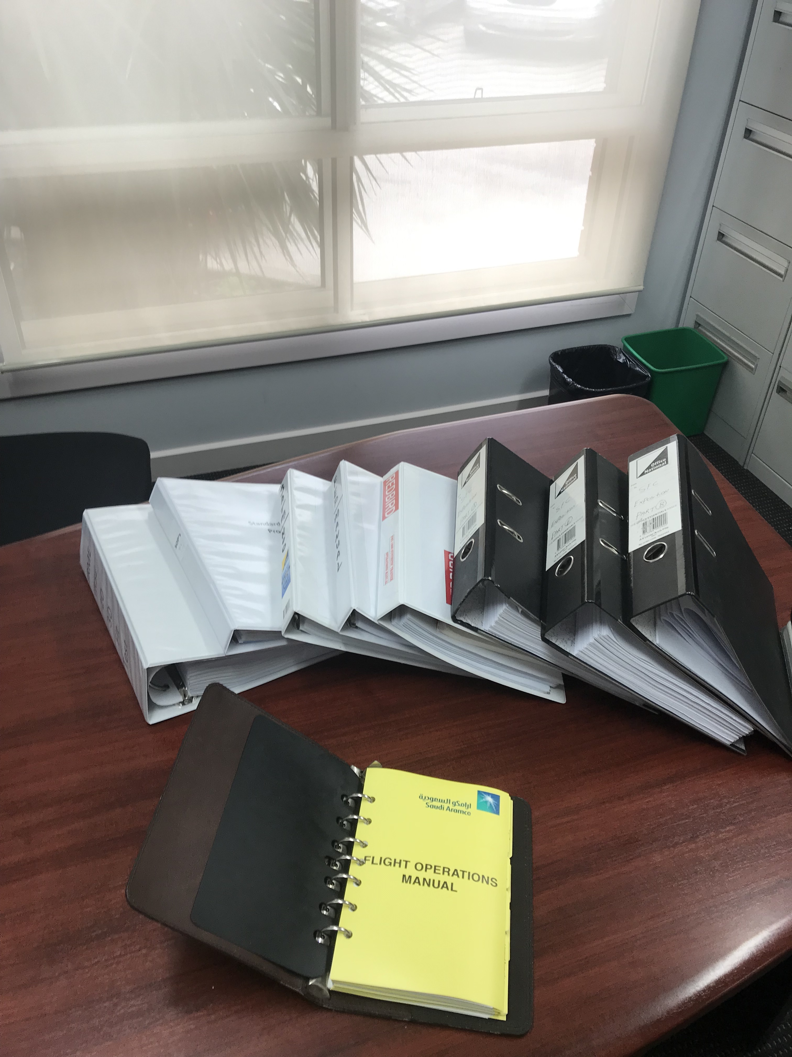

Australian shelfware against a US example

The small binder at the bottom of the picture is a Part 135 fixed wing operations manual for an FAA Part 135 (Charter) operator.

When they employed me they operated:

Six Boeing 737 aircraft
One Boeing 767 aircraft
Eight Bombadier Dash 8 aircraft
Two Gulfstream G5 aircraft
Two Hawker 1000 aircraft
Two Citation 550 aircraft
Four Air Tractor agricultural Aircraft
Two Twin Otter STOL aircraft

The FAA approved manual may seem small considering the number and complexity of the aircraft they operate.

However all aircraft manufacturers, as part of the certification process, must produce manuals, which contain essential performance data, operational procedures, technical data and maintenance schedules approved by the certification authority. All the information a pilot needs to follow to safely operate their aircraft and engineers to maintain them.

The FAA expects and requires all operators to comply with these manuals.

CASA “Accept” the data contained in the manufacturers manuals, but require an AOC holder to regurgitate the information they contain into Uniquely Australian manuals to mirror our uniquely Australian regulations.

The very sad and incomprehensible fact is that the same aircraft flown by half a dozen operators in Australia would all be operated differently because of the “expert” CASA
FOI inputs second-guessing the aircraft manufacturer.

This is why it costs up to 40% more to operate the same aircraft in Australia as it does in the USA. In the USA you are required to adhere to the manufacturers recommendations.

Take the picture above and all the volumes of Australian manuals required today, and compare with an example from our past, before CASA’s time.

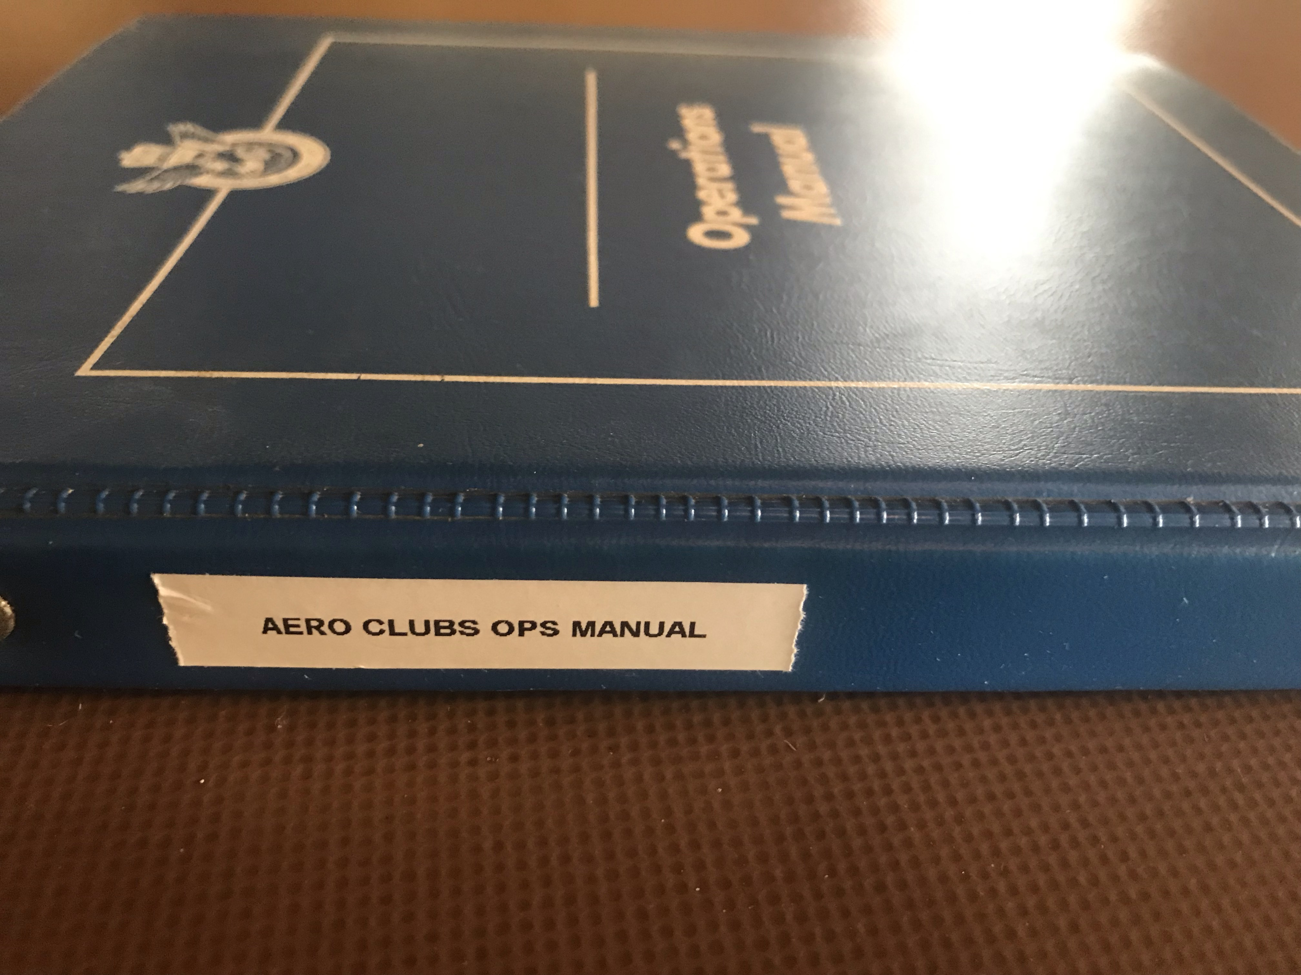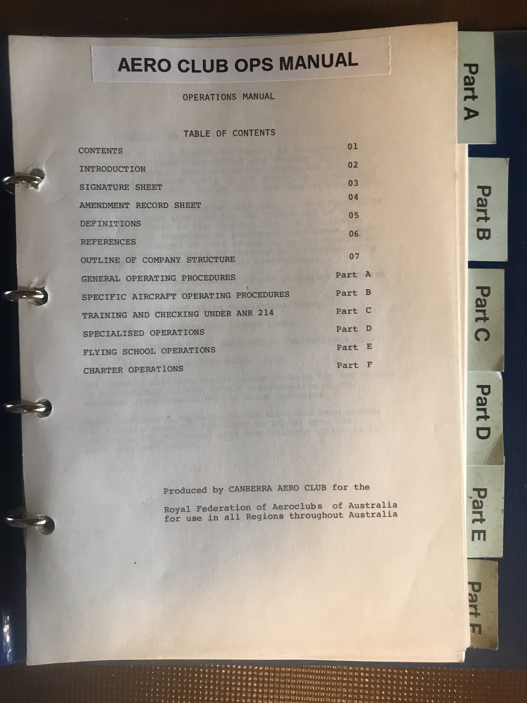

MAINTENANCE

Australia’s unique and complex maintenance regulations are forcing more and more heavy maintenance offshore.

A medium sized corporate Jet aircraft was recently ferried to the USA for a major maintenance check, saving a quarter of a million dollars compared to the quoted price in Australia.

Our smaller operators do not have the luxury of offshoring, the tyranny of distance makes it impractical, they must pay the price.

(More information regarding maintenance issues and solutions may be accessed on the Aviation Maintenance Repair and Overhaul Business Association (AMROBA) website.)

Has the current and ever increasing level of micro management of aviation by CASA made Australia any safer?

LEGAL QUESTIONS

Why was the regulation of aviation placed under the criminal code, reversing the onus of proof with strict liability?

Very few first world countries have aviation laws in the criminal code.

Much of Australian regulation is esoteric and subjective by nature not objective.

As an example, specific speed limits apply in certain areas. Technically it is impossible to fly an exact speed in an aircraft, there are just too many external factors at play.
The law says you must not breach a certain speed. CASA sets tolerances in the Manual of standards (MOS) of plus or minus an increment and imply you may remain within this tolerance. But is this what the law says?

Pilots today spend more time today debating compliance issues than planning and executing a flight.

Every pilot in Australia would be technically in breach of the “Law” at some time every time they fly. The subjective opinion of CASA dictates prosecution for an alleged offence or not.

The penalties applied are quite horrendous even for trivial offences, such as failing to produce a logbook in the required time limit. The huge fine that can be applied if you happen not to be able to prove your innocent is nugatory, when one considers that a criminal conviction essentially ends a pilot’s career.

Many countries in the world will not allow entry if you have a criminal conviction.

Imagine the general public’s reaction if a minor traffic offence resulted in a criminal conviction that ended their career or prevented them from overseas travel.

Our understanding is that a cadre of eastern European lawyers employed by CASA some years ago introduced strict liability. Some of these lawyers were actually ex Stasi lawyers.

It was implemented largely to make it easier and cheaper to gain convictions against pilots and engineers.

CASA will say as a citizen of Australia you can always appeal to Administrative Appeals Tribunal (AAT) or the High Court.

The AAT is supposed to be a non-confrontational low cost tribunal to review a government agencies decision. CASA views it as a court where normal rules of evidence do not apply. The high-powered legal teams they employ for AAT hearings skews and distorts the whole purpose of the AAT.

We will say the law is for everyone; justice however, is for those that can afford it.

Some have tried but you need very deep pockets. CASA has the public purse to draw on.

A quote from one AOC holder who ran afoul of CASA over a safety disagreement with an FOI.

“It cost me a million dollars for lawyers to find out CASA can do whatever it wants”

In the past twenty years just how much money has CASA spent on legal representation?

Has CASA proved itself to be a “Model Litigant” in the legal arena?

There is ample evidence of CASA and its minions falsifying or omitting evidence, swearing false statements and committing perjury. Even when they lose in the AAT or they cannot convince a DPP to prosecute they can still act administratively or destroy who they believe are miscreants by rumour and innuendo or direct threats to people who employ them.

Consider Dominic James and the Pel Air imbroglio. Publicly declared guilty by the CASA Director of Aviation Safety (DAS) before a very flawed ATSB report was even completed. Was he charged with an offence? Did he face a jury of his peers? He freely admits he made some errors of judgement, but he broke no laws. Yet he spent eight years in a CASA manufactured purgatory and is only now getting his career back on track.

There is complete lack of trust within the industry, of CASA and what they are capable of. Whether this lack of trust is unfounded or not, it exists, impeding the free flow of information between the GA industry and CASA, which in itself has a detrimental effect on safety.

CASA’s maintains is it is first and foremost a “Safety Regulator” that is its sole function.

It is what the ACT passed by parliament mandates them to do, regulate for safety and safety alone.

All very well but:

There is no definition in the ACT as to what is meant by “Safety”. How safe is safe?

“Safety Management” should really mean “Risk Management”

But what is acceptable risk?

CASA is the one who sets the bar, varying it as suits.
They do so without scrutiny or oversight from anyone and have proved to be very inept risk managers.

ON THE COMMERCIAL SIDE

Compared to thirty years ago there is very little Ad Hoc charter today, the same need is there, however it’s become just too expensive.

Charter work used to be the training ground for the next generation of airline pilots.

By way of example of cause and effect, a small charter operator had a long-term customer whose executives they flew to a rural location with no regular air service, every week. Over the years costs grew, the charter price grew and the service was cut to fortnightly, then monthly, until the company decided a limit had been reached and began flying their executives to a location by airline then renting a hire car and driving the rest of the way.

The unfortunate consequence was, not long after ceasing their charter flights; several of their executives were killed in a tragic road accident.

We are all horrified by the road safety statistics. Do we endeavour to improve road safety by legislating draconian, endless rafts of regulation that severely limit road use as we do with aviation? Statistically its much safer to travel by air.

There is no doubt that CASA’s unique regulations have added significant unsustainable costs to the General aviation industry. Compliance costs are not easily absorbed or passed on. Margins for charter are very slim, capital costs are enormous, and the users of charter are very price sensitive.

The major airlines do not face these issues to the same extent. Economy of scale means they can spread the costs, a few dollars on the price of a ticket largely goes unnoticed by its customers.

The steady increase in the cost of doing business over the years has been disastrous for all sides of GA, witnessed by the severe decline in commercial aviation activity.

FLYING TRAINING

THE WALL

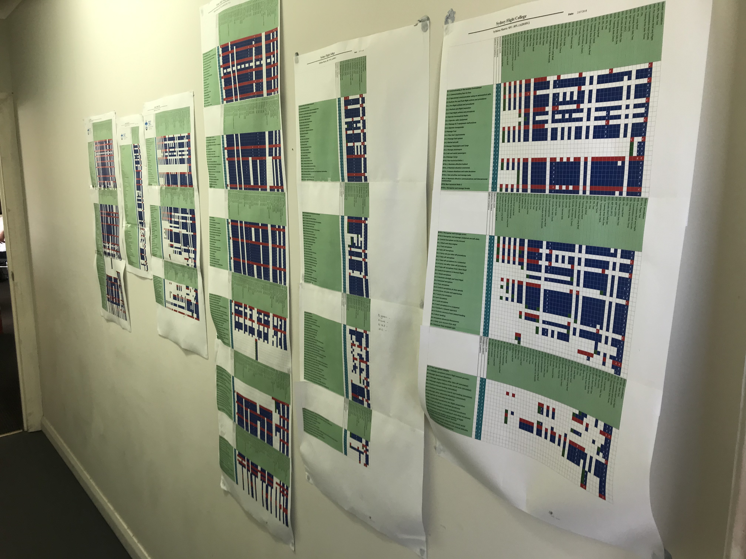

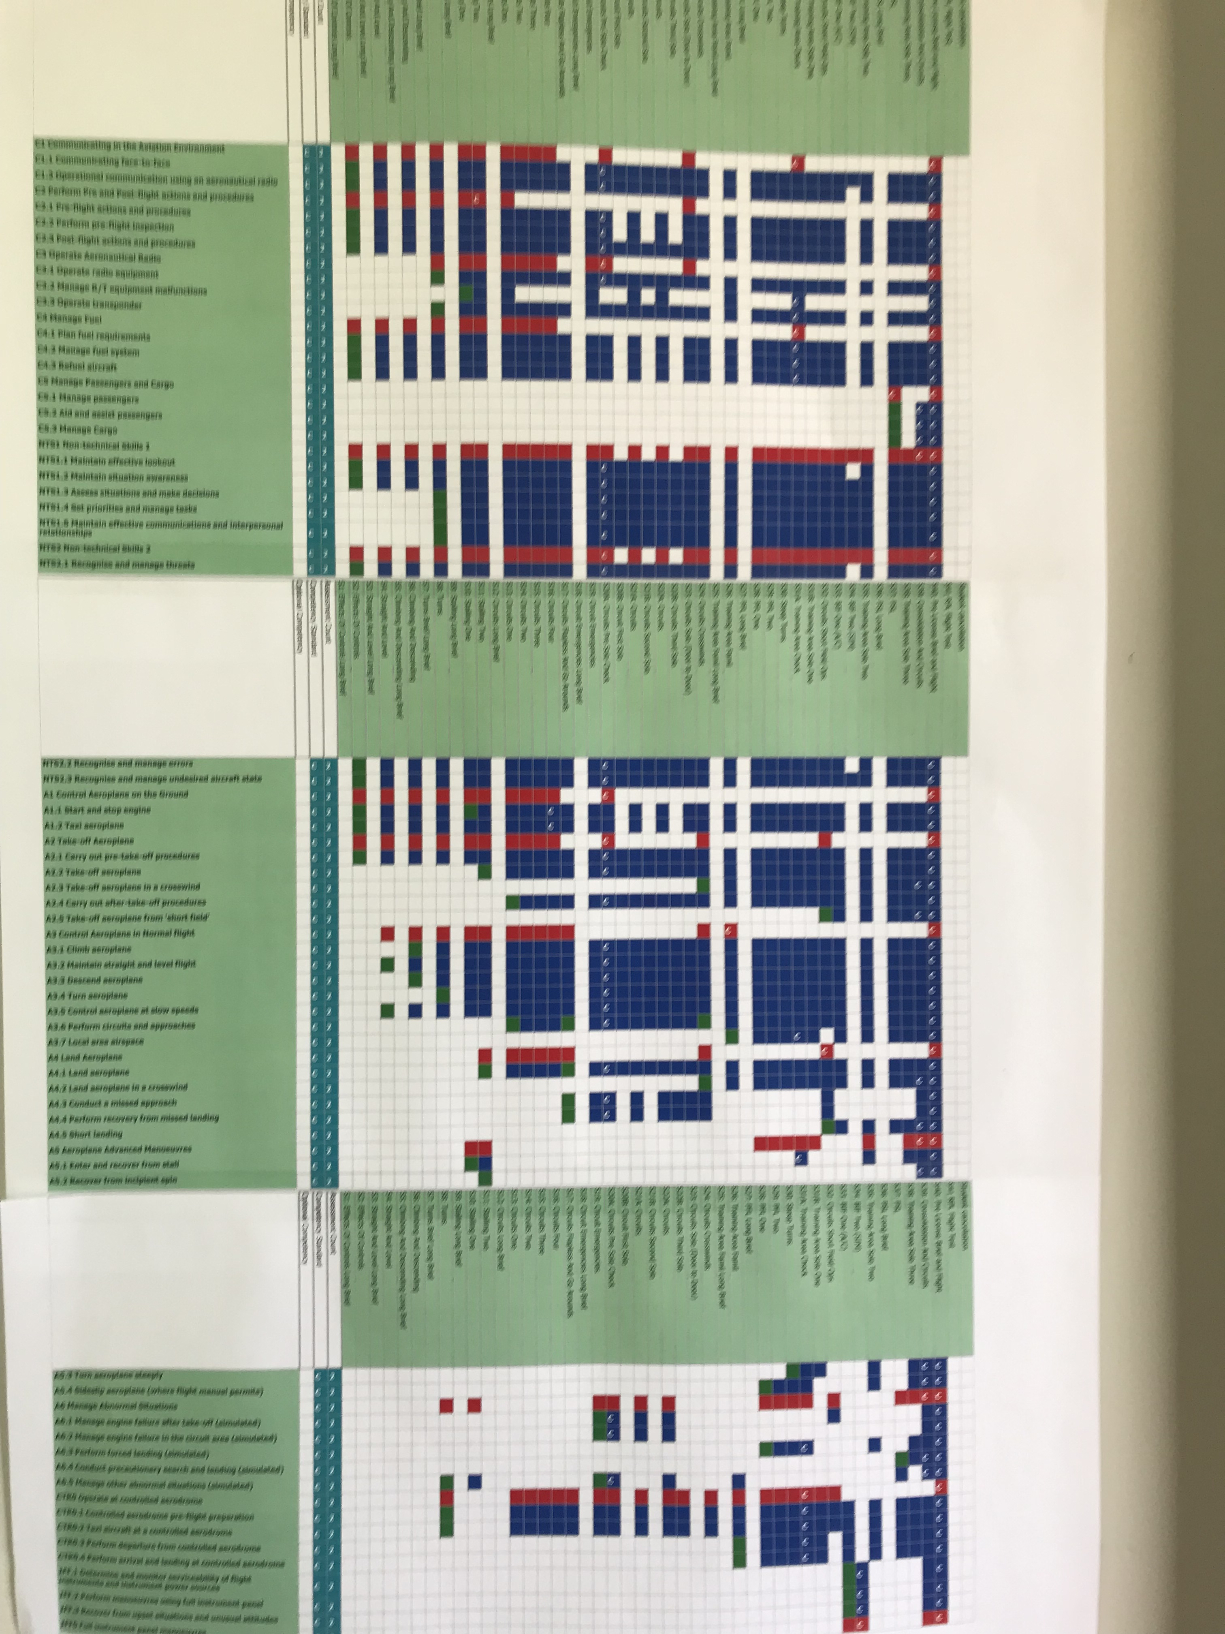

The above pictures are of a wall leading to the instructor’s office of a flying school.

The posters represent the “Competencies” each student must complete to be compliant with the Part 61 Manual of Standards (MOS).

The wall is only about half complete,

By the time it is finished they may need a longer wall. I would challenge anyone to peruse the Civil Aviation Safety Regulations (CASR) Part 61 Manual of Standards (MOS) document and try and make sense of it all. In reality the MOS is an attempt to micromanage flying training to the Nth degree and somehow quantify common sense.

A Quote from an Operations Manual writer:

“Several years ago I was involved in writing a Part 142 Exposition for a medium sized flying school. There was much back and forth with the CASA FOI as I tried to meet each of the 450 tick box items he had to sign off before we gained approval.
When one piece of feedback came back to me stating that nowhere in the document had I mentioned that the Flying School’s facilities had ‘climate control’ I knew there was something grossly wrong with the system. The cost of that Part 142 Exposition (in addition to a Training Management System and Staff Training and Checking Manual that had to be written as well) I estimate would be somewhere in the vicinity of $50-75k. And that manual did nothing to improve safety - all it did was explain the procedures the flying school currently operated under. And I fear all it will have done is create additional burden every time the school has an audit.
A fun fact - the new manuals totalled about 30,000 words. That equates to about 1500 words for every aircraft the school had....for no discernible increase in safety”

Flying training has become a box ticking exercise under CASR Part 142 and Part 61. Instructors spend more time ensuring compliance, ticking the right boxes, than actually teaching students the fundamentals of flying an aircraft.

Flying training and checking at whatever level is very complicated and buried in paperwork.

An example. The picture below is of the forms required by CASA to complete yearly recurrency training overseas for a medium corporate jet. These do not include certified copies of all the approvals and certifications of the provider that must be supplied and returned to CASA year after year.

In the US, EU, Canada, NZ, a one-page form will do

Training and checking can no longer be conducted in advanced aircraft in Australia. Operators must utilize foreign providers because CASA mandates that emergency training can no longer be carried out in certain aircraft, after a tragic training accident

A simulator must be utilised.

There are no representative simulators in Australia the cost is prohibitive .

Overseas training is an inordinately expensive exercise.

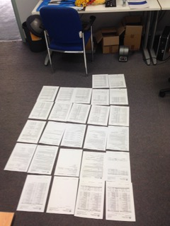

The picture below is from history. It’s the old instructors manual issued by CASA’s predecessor; The Department of Transport Publication 45 was the instructor’s bible. Most of the more senior pilots in Australia’s airlines today would have been trained under it.
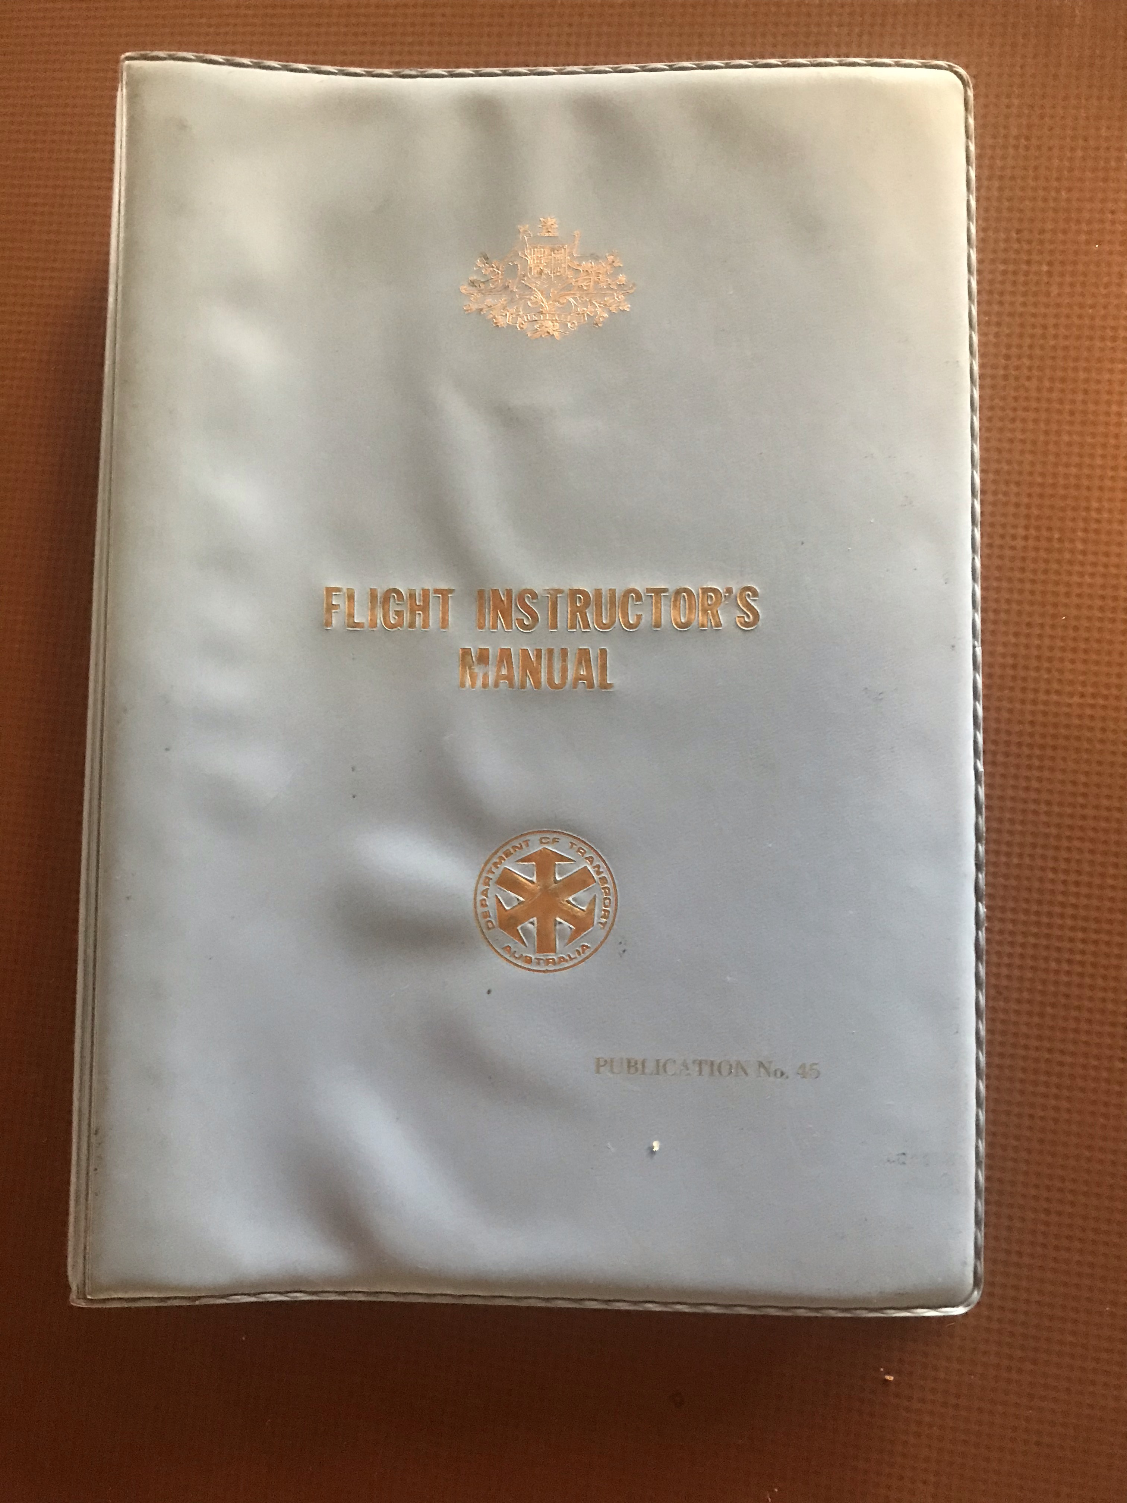

This book enabled a senior instructor to set up shop anywhere in the country and teach, something that can no longer be done without spending inordinate amounts of money on all the micromanagement CASR part 142 and the attendant MOS requires.

In the past the little blue book had all the standards and syllabus required.

In the USA independent flying instructors train almost 80% of pilots.

In the past almost every substantial country town had a local aero club.

There are precious few today.

Have CAsA’s new micromanaged MOS improved standards?

There are many in Industry would say the standard has in fact declined.

One thing is certain; the cost of gaining a license has dramatically increased.

If not for government subsidy there would be very little flying training happening in Australia.

Flying training is contracting to a few large operators who can afford to navigate the bureaucratic morass CASA has created, or sold off to foreign operators to train foreign students to foreign standards.

US flying schools are advertising training to Australian at half our costs including the cost of converting a US licence to an Australian one. New Zealand would be more convenient but there are wait lists to get into their colleges.

ON THE PRIVATE SIDE

There are hundreds of GA aircraft sitting in hangers or paddocks gathering dust, some say more than are flying. The cost of maintaining them under Australian rules is just too onerous.

Many private pilots are giving up their hobby. Keeping a class 2 medical and the costs making private flying unaffordable or just too much trouble, besides who wants to end up a criminal.

Licences are issued in perpetuity. The best guide to active pilots is who holds a medical. The table below speaks for itself we believe, it is derived from CASA’s own statistics.

The class one figures are distorted by foreign students studying at increasingly foreign owned schools and foreign pilots imported to make up the short fall in Australian trained pilots.

FUNDAMENTAL QUESTIONS:

CASA maintains it is one of the foremost regulators in the world.

Is it? Against what and who do they measure that?

If CASA rules are so superior, who in the world is adopting them?

Anyone? Most in our region have adopted New Zealand regulations.

Can CASA explain why this is so?

Is Australia the safest place in the world in which to aviate?

Statistics would say it is not and never has been. The USA is well ahead of Australia in safety and its safety record is improving year on year.

Australia’s have remained static or declined.

Is Australia one of the most expensive places in the world to commit Aviation?

Comparison would say we are.

In the early 1980’ies it was decided to adopt US regulations, but abruptly, having made a start, Australia suddenly decided to adopt new EU regulations.

Why was this so?

When one considers the aviation industry in the USA is bigger than the world combined, where most of our aircraft and equipment come from, why would we consider new untested regulations instead of aligning with mature, tested US rules.

The EU regulations proved to be a disaster and virtually destroyed their general Aviation Industry.

They are now in the process of rewriting them.

Who decided to change from US to EU rules?

Ultimately Australia went its own way and wrote its home-grown hillbilly version.

PLAIN ENGLISH?

CASA is currently producing a manual explaining their rules in Plain English. An example is on their website.

This begs the question

Why didn’t we write them in plain English in the first place?

We paid half a billion dollars and so far thirty years to produce the amateurish, convoluted, indecipherable rules we have now and their not even finished yet.

Will the new plain English guide cost another half billion dollars?

To explain the unexplainable

CASA maintains we cannot write our rules in plain English and therefore cannot adopt US or NZ rules because they are not compatible with our Westminster system of government.

New Zealand has a very similar parliamentary System to us and they had no trouble adopting US rules in plain English. They largely copied the most successful and safest rule set in the world, the US Federal Aviation Regulations (FAR’s). Took them two years and a few million dollars.

Is CASA an honest regulator?

They regulate not in the interests of the industry nor the interests of the Australian public. They act in their own self-interest driven by power, ego and money, largely to absolve themselves from any liability.

They have made themselves unaccountable to anyone, the industry, the minister, the Law and the parliament.

They hide behind the Mystic of Safety, promote themselves as experts when Con men would be a more apt description.

They have squandered almost half a billion dollars of public money to produce a rule set that is unworkable and has not produced the nirvana of safety they promised.

New Zealand takes the prize, as they increasingly do in the common sense stakes and copied the best, simplest and safest regulatory suite in the world the US FAR’s

They are reaping the benefits.

CAN GENERAL AVIATION BE SAVED?

There are many who believe it is too far past its tipping point to be saved.

We believe there is still hope provided there is political support and will.

For a start change the ACT.

The ACT currently requires CASA to only consider Safety. The level of Safety is not defined in the ACT. This conveys to CASA extraordinary power. It is left to them to decide what Safety is, with no oversight, checks and balances.

In the USA and other like jurisdictions, their equivalent acts temper the power of their regulators. In the US aviation Act the FAA must not only regulate for safety, they must foster and promote their industry. This restrains any tendency to over regulate, ensures meaningful risk management and the perceived risk measured against the economic cost of mitigating it.

An Audit

The words “Hostile Audit” sends shivers down the spine of any AOC holder in Australia because invariably it means their business is about to be shutdown.

There have been many inquiries over the years critical of CASA, such as the 2008 inquiry into the administration of CASA . The ASRR report, (aka) The Forsyth report, to name just two.

CASA either ignored them completely or referred to them as “Opinions” only.

Without political intervention, they simply swept them under the carpet.

We are aware politicians and bureaucrats are reluctant when it comes to inquiries. What’s Sir Humphries old line? “Never hold an inquiry unless you’re sure of the outcome”. CASA it would appear subscribe to Sir Humphries ethos.

Facing increasing strident criticisms, they attempted to bury them by holding their own inquiry, making very sure the outcome was to their advantage.

Isn’t it time to hold an independent inquiry into CASA?

An inquiry with some weight such as a judicial inquiry or a royal commission that can get to the truth.

New Zealand experienced some false starts on their road to true reform; it took a royal commission to finally get it there.

It is blatantly obvious or it should be, that Australia’s half billion-dollar reform project has been an abject failure. It has not achieved safer outcomes as it was supposed to do. Its only achievement has been to dramatically drive up cost and complexity, resulting in a steady decline in general aviation activity.

If an inquiry finds this is true, then Australia should do the sensible thing as New Zealand did and adopt the US FAR’s. Cost NZ less than $5 million and took a couple of years. This can be done by Australia, but will need new personnel in charge of CASA and a reforming Director of aviation safety (DAS) Someone like Mike Smith, rejected when the position was last advertised.
Mr Smith was a senior manager with CASA, he knew which cupboard the skeletons are in. He also had vast experience with regulatory matters working with ICAO. He currently runs a successful GA flying business in the USA, he also holds Australian and US qualifications as an engineer and pilot, he was the Industries choice for DAS.

Instead we got a career bureaucrat with no real background or expertise in Aviation.

Someone of Mr Smith’s calibre is essential, someone with intimate knowledge of the industry, both in Australia and where GA is successful. Perhaps more importantly any

candidate would need the ability to deflate the competing, opinionated ego’s that reside in the upper levels of CASA management.

To be successful CASA will require a complete change of culture.

CASA have morphed into what many would describe as a police force. Their attitude is egotistical, aggressive and authoritarian rather than cooperative and consulting.

There must be increased political oversight, The Minister with an Industry Standing Committee to oversee Civil Aviation including Airport Policy.

Where can GA take us?

Bankstown Airport once employed thousands people directly involved in aviation, today less than 250.
Ref: Bankstown Airport Historical notes for a heritage assessment August 2009

Unshackling the industry from the red tape that binds it would allow a resurgence of participation and see the industry recover to healthy growth. All it takes is one good idea and the freedom to allow it to grow. There have been many great innovative ideas in aviation in Australia over the years, driven away by the wall of indifference and shackled by red tape.

General Aviation always had its roots in regional Australia, in fact that was where QANTAS had its beginnings. A vibrant growing industry would provide jobs and services to the “bush” lost from over regulation.

In the USA general aviation employs 1.3 million people and contributes more than 1% to the country’s GDP. (AOPA USA)

In Canada General Aviation contributes $9.3 Billion to the Canadian economy
And employs over 20,000 people. (AOPA Canada)

In New Zealand all Aviation contributes almost 3% to their GDP and employs over 20,000 directly and indirectly.

