To Whom it may concern:

In regard to the question of whether the engine failure of VH-WTQ was caused, or contributed to, by carburettor Icing:

I, Dafydd John Llewellyn, of 779 Saddletop Road, Clifton 4361, am a retired (77 years) aeronautical engineer. I am, amongst other things, accredited by CASA as a test pilot for flight testing to establish compliance of single-engined aircraft (such as the Cessna 172) with the design standards prescribed in the Civil Aviation Regulations; and I have held aircraft design authority under the Civil Aviation Regulations from 1974 onward; my CV is attached as Appendix 1 to this document.

Engine installations for single engine aircraft is one of my areas of design authority.

Carburettor icing occurs when the fuel spray in a carburettor, impinging on parts of the carburettor, especially the throttle “butterfly”, cools the air and the metal surface sufficiently for the water vapour in the atmosphere to freeze. In general, the conditions under which it is considered to be likely to occur is shown in the following diagram:
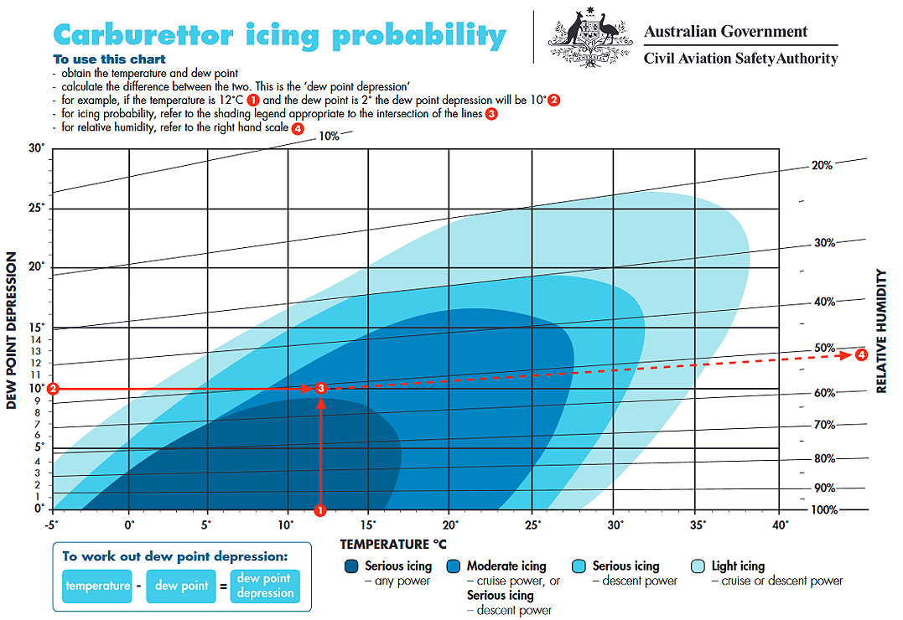
This chart does not take into account the actual metal temperature of the carburettor parts; it assumes they are at equilibrium with the temperature of the air/fuel mixture. This is an accurate assumption for a carburettor installation on a manifold that separates the carburettor from the engine itself, and also from the warm air from the metal parts of the engine, as would be the case if the engine is an air-cooled type and the carburettor is “upstream” of the engine in the sense of the cooling airflow through the engine cowling. It is, therefore, a conservative representation for the “worst case” engine installation – as it must be, to be used as a general guide to pilots. Its relevance to the Cessna 172 Lycoming engine installation is considerably less than this, because of the features of the engine installation in that aircraft type. So it should NOT be assumed that carburettor icing was probable solely on the basis of this diagram.

The VH-WTQ had been re-fitted with a Lycoming 0-320-D2J engine developing 160 horsepower at 2700 RPM (From FAA Type Certificate Data Sheet No. 3A12). The “0” indicates that the cylinder layout is “opposed” – i.e. Horizontally opposed. The “320” is the engine displacement in cubic inches. All Lycoming 0-320 engines are air-cooled four cylinder engine of “opposed” layout, using direct-drive of a propeller bolted to the crankshaft flange. The Model number D2J refers to detail differences within the general design.

From FAA Type Certificate Data Sheet E274, the model D2J has the same carburettor (MA 4 SPA) as do almost all the other models of this engine. This carburettor is a vertical updraft type, mounted centrally on the bottom of the engine sump, whose oil capacity is 8US Quarts, identical to that of the model 0-320-E2A which also has a sump capacity of 8 quarts.

The inlet manifold is largely contained within the engine sump, so that it is heated by the hot oil in the sump; this feature renders these engines relatively immune to induction system icing – unlike the Teledyne Continental engines used in the Cessna 172 early models.

The carburettor throttle butterfly is close to the mounting flange, i.e. at the top of the carburettor in its installed position, so it is close to the engine sump, and thus receives heat from the engine sump. The carburettor uses a large float chamber, located at the bottom of the carburettor. Induction air is drawn in through the bottom of the carburettor and passes upwards through the venturi, within which fuel is sprayed into the rising air, and the quantity of air is controlled by the butterfly valve at the upper end of the venturi.

In 1982, I conducted some instrumented flight tests of the carburettor on a Lycoming 0-320-E2A engine in the Piper PA28-140 aircraft which I owned at the time. This version produces 150 horsepower at 2700 RPM. Both the Cessna 172 and the PA 28-140 use a similar engine installation layout, with cooling air entering via “nostril”intakes in the cowling, into a plenum chamber above the engine, from which the cooling air passes downwards through the engine cooling fins, being constrained to do so by baffling which isolates the upper from the lower cowl zone, and exits via an opening at the lower rear corner of the cowl. Thus the carburettor is immersed in the hot air stream from the cylinders in both cases. This air is usually approximately 25° C warmer than the ambient air temperature when the aircraft is climbing, and closer to the ambient temperature when in a descent with closed throttle. In this discussion, I have assumed that the pilot did NOT use carburettor heat during the descent; if he did, the air temperature going through the carburettor would be some 50° C above ambient, at least for the first two minutes of the descent, because that is a requirement of the Type certification Design Standard. After two minutes, the temperature supplied from this system would decline, due to cooling of the exhaust at low power.

However, my test showed that the temperature in the carburettor bowl was largely independent of the air temperature, but was primarily determined by the fuel flow – in effect, the carburettor was “fuel cooled”, not air-cooled. The carburettor received considerable heat from the mounting flange to the engine sump, despite an “insulating” spacer (which is part of the engine, so not affected by whatever aircraft it is installed in). As a consequence, and quite contrary to what one might expect, the carburettor bowl temperature increased when the aircraft was put into a descent, and continued to rise for some 20 minutes after the start of the descent, due to the heat from the engine sump (and the oil within it). Because the carburettor bowl is further from the mounting flange than the throttle valve, I would expect the body of the carburettor in the vicinity of the throttle butterfly to be even hotter. The throttle valve shaft runs in bearings in the body of the carburettor, so heat would be conducted into it. If icing occurred, the metal inside the ice would be isolated from the cooling effect of the fuel spray, so its temperature would tend to rise, thus melting the ice at the contact surface; under these circumstance, the ice would be continuously dislodged, and so would be highly unlikely to accumulate sufficiently to stop the engine when the throttle was opened.

I have flown behind Lycoming 0-320 engines for approximately 1000 hours, and I have never experienced carburettor icing with one of these engines. The differences between the model D2J and the Model E2A (and others of my experience) would not be expected to significantly alter this conclusion.

The engine of VH-WTQ failed, I understand, when the pilot tried to open the throttle at the end of a descent, some 7 minutes after takeoff. This is within the profile of the test flight that produced the results shown overleaf. I would therefore expect a carburettor bowl temperature of approximately 15° C above the ambient air temperature – and a temperature in the vicinity of the throttle valve higher than that.

I therefore consider that the likelihood of carburettor icing in the case of VH-WTQ to be low, under the circumstances of the accident.



D. J. Llewellyn
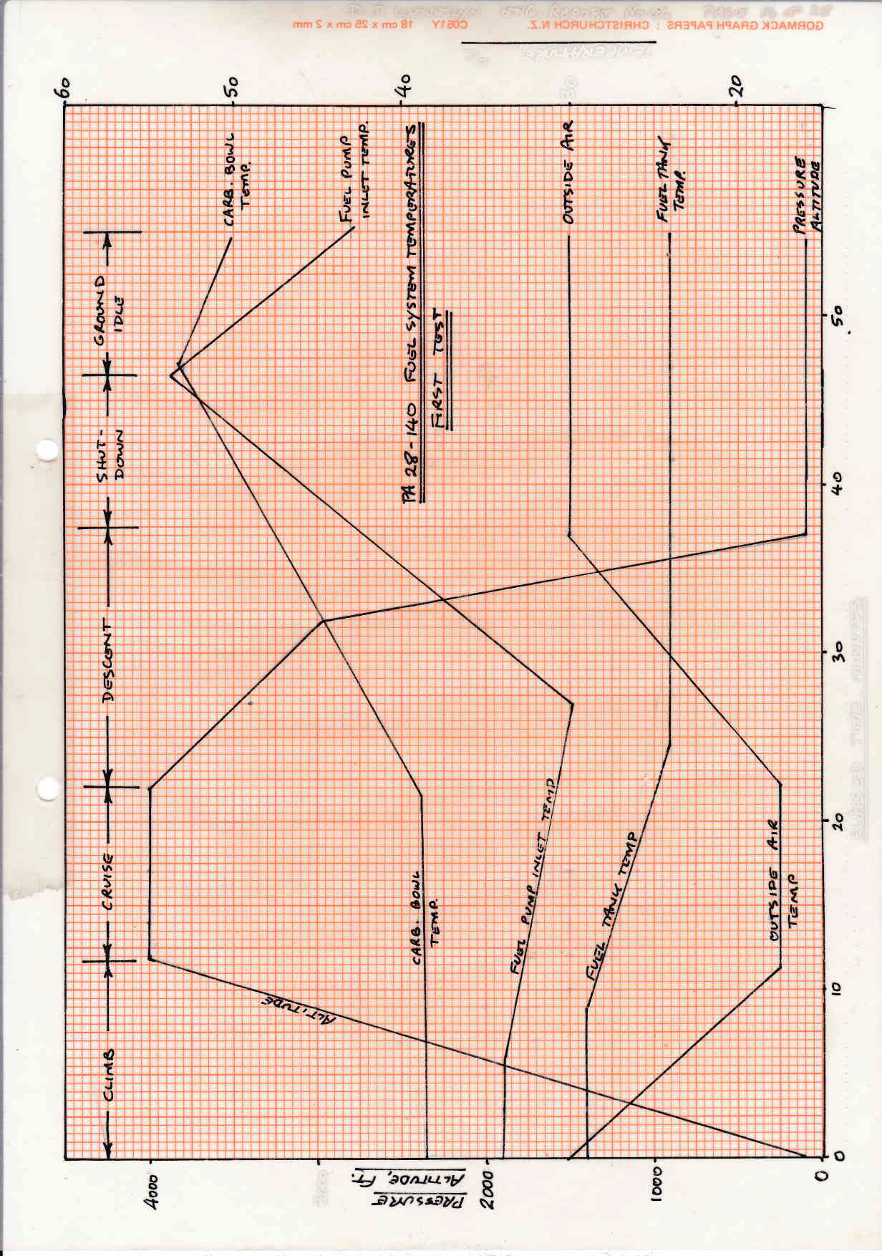

APPENDIX 1 - D. J. Llewellyn Resume:

Name in full: | Dafydd John Llewellyn
Place/Date of Birth: | Melbourne/27/8/41
Nationality | Australian
Profession: | Aeronautical Engineer
Capacity: | Aeronautical Engineering Consultant
Specialisation: | Supervision of aircraft flight test activities.  Aircraft structural design.  Piston engine installation design.  Aircraft performance testing.  Aircraft weight control.  Aircraft welding.
Private: | Married (since 1965). Two sons.
Address: | M.S. 544, Clifton, QLD 4361  Phone 0746 964 550 Fax 0746 964 548  email: dafyddll@bigpond.com
Education: | Bachelor of Engineering (Aeronautical) - Sydney University – 1964
Key qualifications: | Holder of Instrument of Appointment issued by Civil Aviation Authority as Authorised Person for Civil Aviation Regulations 35, 36.(Since 1975) (i.e. aircraft design authority) – now retired  Holder aircraft Weight & balance authority No. AN-27  Holder aircraft welding authority No.WN-557 (not current)  Pilot licence No. 014046; test pilot authorisation for small single- engine aircraft.  Registered Professional Engineer of Queensland since 9/4/91 (i.e. following relocation to QLD); Member Flight test Society Australia
Experience: | (Highlights only)
2005 & later | Weight increase for Seabird model SB7L-360A & flight testing of airflow kit for same. Certification for Seabird model SB7L-360A2 & A3: structural justification and certification flight testing, including full spinning recertification; in conjunction with Mr. Alan Kerr, re-engining with Lycoming IO-390, revision to fatigue life under latest FAA requirement. Certification achieved for the –A2 and –A3 models. Retired from CAR 35 practice in June 2011. Revised STC (SVA-542) for life extension to L-13 Blanik gliders.
2003/2004 | Structural finding of compliance for certification of Jabiru Model 160C
2002: | First person to receive an Instrument of Appointment from CASA as an Authorised Person for the purposes of Civil Aviation Regulations Part 21.33(3) (i.e. to find compliance with the applicable design standard, on behalf of CASA, in the context of type certification of small two-place aeroplanes.)
1999/2000 | One of eight professional engineers delegated by CASA to approve aircraft fuel system decontamination procedures. Awarded Bill Adams Award 1999 by AOPA for services to aviation engineering.
1997/98: | Chairman, substantive working party for review of Civil Aviation Regulations on aircraft type certification and manufacture. (CASR s Parts 21 - 35). Consultant to LADS corporation (Subsidiary of Vision Systems, S.A., for selection & equipment of DHC-8 aircraft for LADS Mk II laser aerial depth sounder survey system.
1996/97: | Member, Program Advisory Panel for review of Civil Aviation Regulations (Appointed by Minister for Transport). Engineer in charge of certification of Jabiru 2200J aero engine and Jabiru LSA/55J aircraft (performed flight tests on the latter). Achieved certification under JAR 22H (engine) and Civil Aviation Order 101.55 for the aircraft.
1993/94: | Engineer in charge of certification program for Seabird “Seeker” model 360 observation aircraft. Achieved certification under Civil Aviation Order 101.22/FAR Part 23.
1992: | Flight test engineer in charge of certification for Seabird “Seeker” model 235 observation aircraft. Certification achieved under Civil Aviation Order 101.22/FAR 23. Founding chairman, Queensland Aircraft Manufacturer’s Association, Inc.
1990/91 | Development & Certification test pilot for Skyfox & Jabiru aircraft, leading to certification under CAO 101.55 for both types.
1989-1991 | Structural consultant (design signatory) to East-West Airlines for modification of Fokker F-27 (VH-EWP) aircraft for Australian Navy Laser Airborne Depth Sounder program. Designed all the structural mods.
1987-1989 | Private Aeronautical consultant; retained by CSIRO to support its F-27 atmospheric research aircraft (VH-CAT) on an ongoing basis. Spent 3 months in France as consultant to SECA (Le Bourget) on F-27 (F-BYAO) mods. for French Scientific Organisation (Institute Geographic Nationale) including nosecone installation, APU in rear fuselage, design of camera and Lidar window installation modifications. Designed modification to Beech 33/35/36 wing to delete “piano hinge” spar design (i.e. a major re-design). Assisted east-West Airlines in tendering for LADS program.
1986 | Performed Acceptance Flight testing (as consultant to ADAB) of 400 HP “AIRTRUK” agricultural aircraft for supply to China as Australian Grant-in-Aid program. (Since this is a single-seat aeroplane, this required the functions of engineer and pilot to be combined.)
1979-1987 | CSIRO - Aircraft Operations Manager (and aeronautical design signatory) for Division of Cloud Physics (1979-83) and Research Aircraft facility (1983-87). Managed scientific co-ordination and aeronautical engineering (modifications) for F-27 VH-CAT. Prepared and monitored tender specifications for subcontract operations and maintenance of VH-CAT. Six persons under direct control. Acted as interface between Dept of Aviation/CSIRO/East-West Airlines. Called as Expert Witness in two major aeronaurical cases (SA Supreme Court and A.A.T.) Designed, supervised installation and testing of numerous major and minor mods to F-27 including instrument pods, installation of nosecone, design & development of on-board GPU etc.  (The Research Aircraft Facility had developed its expertise sufficiently by 1986 to perform a major proportion of the design of the aircraft sub-system for LADS; it also sold engineering and hardware to the French for major modifications of their F-27 atmospheric research aircraft to the value of $170,000.)
1975-79 | Private aeronautical consultant - various structural modifications and G.A. perfomance testing. Designed fatigue life extension mod. for L-13 Blanik sailplane to extend life from 4000 to 12000 hours (STC granted) (Awarded Ryan Medallion by Gliding federation). STC for re-engining PA18, Auster.
1970-74 | Dept of Civil Aviation, NSW Region, Major Projects section - general aeronautical engineering - investigated Bensen “Gyrocopter”; Aeroelastic analysis pylon-mounted “pods” on aircraft - accident investigation (various) including inquest. Regional Technical Officer (airworthiness) for NSW Gliding Association.
1969-1970 | International Combustion (Rydalmere, Sydney) - Design and investigation of vibratory feeders.
1968-69 | Private aeronautical consultant in conjunction with Mr. J. Blackler. Design of Sydney double-deck bus bodies for Pressed metal Corporation. Design of mast & rigging 12 metre yacht Gretel II.
1966-69 | Hawker de Havilland, Milperra Road branch (Sydney). General aeronautical design (mods & repairs); aircraft weight and balance; aircraft performance testing & reduction. (went to New Guinea as company engineer-in-charge tropical performance testing of Twin Otter aircraft 1967, as prerequisite for introduction into airline service by TAA).
1964-1966 | Victa Consolidated Industries - Aeronautical design engineer (Victa Aircruiser & Gyroplane projects).

Incidentally, I hold a low-level endorsement from CASA, because I commonly conduct flight tests which involve starting a climb from as low a level as possible; I normally do this over the Pacific Ocean, close to a beach.

